|  |  |  |
| --- | --- | --- |
|  |  | Top 500 80’s Dance classics  Presentatie: Ricky Carlo Da Wbro |

Datum: 22-12-2022

# The Soul Funk Edition: Top 500 80’s Dance Classics

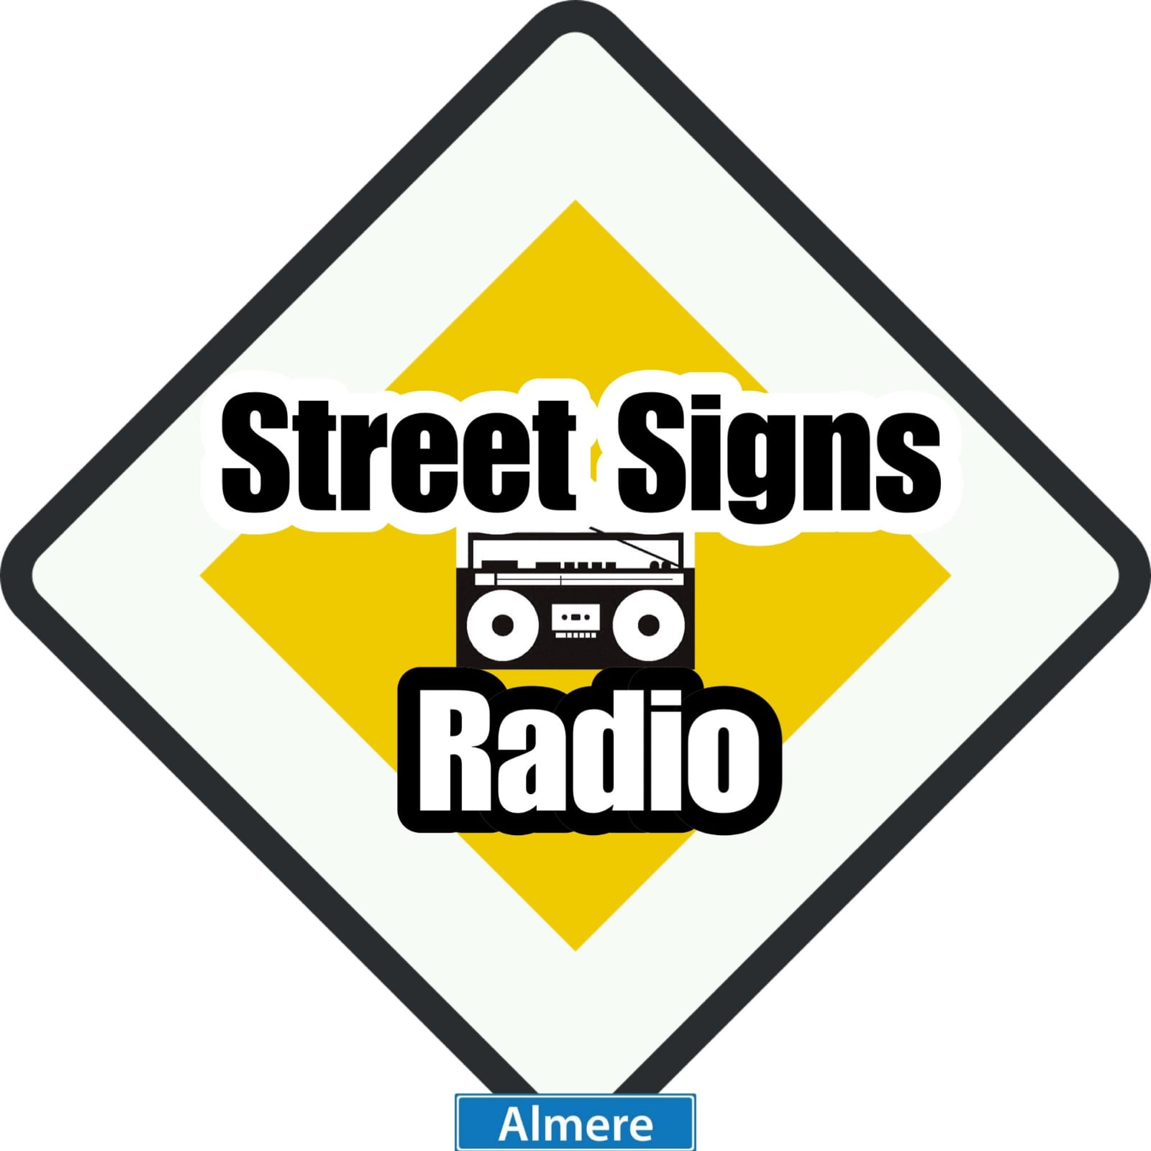

## Top 500 80’s Dance Classics :

1. The B.B. & Q. Band – Starlette.
2. Dayton – The Sound Of Music.
3. Narada Michael Walden – I Want You
4. Cherrelle – When You Look In My Eyes
5. The Ritchie Family – I’ll Do My Best
6. Alexander O’Neil – Criticize
7. Chic – You Are Beautiful
8. Evelyn ‘Champagne’ King – Back To Love
9. The Cool Notes – Spend The Night
10. Marz – Move it, Groove It
11. Rochelle – Mt Magic Man
12. The S.O.S. Band - Take Your Time ( Do it Right )
13. Loose Ends – Hangin’ On A String
14. The Jones Girls – Nights Over Egypt
15. Change – Heaven Of My Life
16. Bruce Grant – Enough Is Enough
17. Starpoint – Sensational
18. High Fashion – You’re The Winner
19. Glenn Jones – Iam Somebody
20. The System – Guardian Angel
21. Fatback – I Love Your Body Language
22. Tavares – Keep On
23. Paradise – Back Together
24. Gary Taylor – Looking Back
25. Stacy Lattisaw – Feel My Love
26. Freda Payne – In Motion
27. Attitude – I Wanna Get To Know You Better
28. Five Star – Let Me Be The One
29. Love Club – Hot Summer Nights
30. Linda Lewis – Style / Class
31. George Benson – Give Me The Night
32. James Ingram – Never Felt So Good
33. Mtume – Juicy Fruit
34. Ollie & Jerry – There’s No Stoppin’ Us
35. Total Contrast – Hit & Run
36. Jeff Lorber Band Feat. Gavin Christopher – This Is The Best Part Of The Night
37. Surface – Falling In Love
38. Kashif – Lover Come Turn Me On
39. Lionel Richie – Serves You Right
40. Vesta Williams – Don’t Blow A Good Thing
41. Skyy – Jealousitis
42. Chic - Stage Fright
43. Norman Connors – Take it To The Limit
44. Larry Wu – Let Me Show You
45. Komiko – Feel Alright
46. T.S. Monk – Fantasy
47. Flow Chart – Ask The Boss
48. Peter Jacques Band – Mighty Fine
49. Millie Scott – Automatic
50. Teena Marie – Square Biz
51. Norma Jean Wright – Love Attack
52. The Jets – Rockit To You
53. Delegation – It’s Your Turn
54. Diana Ross – My Old Piano
55. Stephanie Mills – You Putting A Rush On Me
56. Bryan Loren – For Tonight
57. Conquest – Body Movement
58. Mason – Crazy Life
59. Chaka Khan – Can’t Stop The Streets (Krush Groove)
60. Maze Feat. Frankie Beverly – Before I let Go
61. Mercy Mercy – What Are We Gonna Do About It
62. Mai Tai – History
63. Rick James – Ghetto Life
64. Midnight Express – Danger Zone
65. The Blackbyrds – What’s On Your Mind
66. Pointer Sisters – Just A Little Closer
67. The Main Ingredient Feat. Cuba Gooding – Party People
68. The Strangers – Step Out Off My Dreams
69. Liz Hogue – Vicious & Fresh
70. Satin Silk & Lace – Your Love
71. Inner Life – The Moment Of My Life
72. Howard Johnson – Let This Dream Be Real
73. The System – You Are In My System
74. Thelma Houston – You Used To Hold Me So Tight
75. Klymaxx – Meeting In The Ladies room
76. Patti Austin – Hot In The Flame Of Love
77. Bloodstone – Funk Around
78. Jaki Graham – Round And Round
79. Kleeer – Intimate Connection
80. Captain Rapp Feat. Kimberly Ball – Bad Times
81. Jane Child – I Don’t Wanna Fall In Love
82. Princess – Say I’m Your Number One
83. Rufus & Chaka Khan – Ain’t Nobody
84. Body – Do You Still Love Me
85. Steve Shelto – Don’t You Give Your Love Away
86. Val Young – Mind Games
87. One Way – Cutie Pie
88. Zinc – Street Level
89. Valerie Oliver – Get The Money
90. Donald Byrd & 125 Street – Sexy Dancer
91. René & Angela – Rise
92. Nia Peeples – Poetry In Motion
93. Serge Ponsar – Out In The Night
94. Booker Newberry – I Get Romantic
95. Phyllis Hyman – If You Want Me
96. The Sylvers – Bizarre
97. Curtis Hairston – The Morning After
98. Slave – Party Lites
99. Sunfire – Never Too Late For Your Lovin’
100. Val Young – Mind Games
101. Yvonne Gage – Garden Of Eve
102. Network – I Need You
103. Slave Feat. Steve Arrington – Nobody But You
104. Sharon Redd – You Got My Love
105. Jeannette ‘Lady’ Day – Come On Let me Love You
106. Chapter 8 – Understanding
107. The Gap Band – Outstanding
108. Marie Malloy – I Surrender
109. Feel – Let’s Rock
110. Angela Winbush – C’est Toi (It’s You)
111. France Joli – Your Good Lovin’
112. Unlimited Touch – Searching To Find The One
113. Take 3 – Tonight’s The Night
114. O’ Bryan – Lovelight
115. Intrigue – Forever Together
116. Phyllis St. James – Ain’t No Turning Back
117. Lillo Thomas – You’re A Good Girl
118. Freddie Jackson – I Wanna Say I Love You
119. Juicy – Sugar Free
120. Boeing – Dance On The Beat
121. Nona Hendryx – B-Boys
122. The Limit Feat. Gwen Guthrie – Say Yes
123. The Whispers – Tonight
124. The O’Jays – Put Our Heads Together
125. Unique – What I Got is What You Need
126. Visions – You Gonna Be Mine
127. Windjammer – I Thought It Was You
128. Xavier – Do It To The Max
129. High Fashion – Love
130. Sybil – Falling In Love
131. Sister Sledge – Fool Around
132. The Players Association – We Got The Groove
133. Caprice – 100 %
134. Leroy Burgess – Heavenly
135. Dayton – Out Tonight
136. Clarity – The Way You Make Me Feel
137. Bobby M Feat. Jean Carne – How Do You Feel Tonight
138. Reel 2 Reel – Love Me Like This
139. Level 42 – When The Sun Goes Down
140. Con Funk Shun – Ain’t Nobody Baby
141. The Bar- Kays – She Talks To me With Her Body
142. Teena Marie – I Need Your Lovin’
143. Millie Scott – The Key
144. Stephanie Mills – Can’t Keep Runnin’ From My Love
145. Mason – Living On The Edge
146. Band Of Gold – Never Gonna Let You Go
147. Fatback – Is This The Future?
148. Melba Moore – Take My Love
149. High Fashion – Hold On
150. Loose Ends – Ooh, You Make Me Feel
151. The Cool Notes – Come On Back To Me
152. The System – I Wanna Make You Feel Good
153. Junior – Mama Used To Say
154. Glenn Jones – Meet Me Halfway There
155. Chic – Chip Off The Old Block
156. Brenda Watts – Who Needs A Love Like That
157. The Jammers – Out To GetYou
158. Jocelyn Brown – Love’s Gonna Get You
159. Fatback – She’s A Go Getter
160. Convertion – Sweet Thing
161. Change – A Lover’s Holiday
162. The B.B. & Q. Band – Time For Love
163. Evelyn ‘Champagne’ King – Love Come Down
164. Jerry Knight – Fire
165. The Emotions – You’re The Best
166. Tom Brown – Funkin’ For Jamaica
167. Donna Allen – Serious
168. Ian Foster – Heaven (Send Your Love To Me)
169. Funk Deluxe – This Time
170. Skyy – Here’s To You
171. Ze-Brass – Feels So Good
172. Luther Vandross – Sugar And Spice
173. Cherrelle – Will You Satisfied
174. Dayton – Nobody Else
175. Pia Zadora – Still Remembered
176. Surface – Stop Holding Back
177. Marz – One More Minute
178. Vaughan Mason – Bounce, Roll, Skate
179. Starpoint – It’s All Yours
180. Alexander O’ Neal – What Can I Say
181. Bryan Loren – Easier Said Than Done
182. Mtume – H.I.P.S
183. Cameo – Single Life
184. The Reddings – Come Back To Me
185. Aurra – Coming To Get You
186. Grady Harrell – Put This On Your Mind
187. George Benson – Inside Love (So Personal)
188. Eugene Wilde – Personality
189. Secret Weapon – Must Be The Music
190. Diana Ross – Who
191. The Jacksons – Everybody
192. Fatback – Just Be My Love
193. Lillo Thomas – Let Me Be Yours
194. Darlene Davis – Love Lines
195. September – Are You Free Tonight?
196. Network – Cover Girl
197. Kashif – Stone Love
198. C.O.D. – In The Bottle
199. Linda Taylor – Don’t Lose The Motion
200. Melba Moore – Never Say Never
201. Sekou Bunch – Pretty Baby
202. Willie Collins – Where You Gonna Be Tonight?
203. Lorber & White – True Confessions
204. Kool & The Gang – Big Fun
205. Rose Royce – Love Me Right Now
206. Dino Terrell – You Can Do It
207. Passion – Don’t Stop The Love
208. Madonna – Lucky Star
209. World Famous Dream Team – Hey DJ
210. Central Line – Time For Some Fun
211. P-Funk Allstars – Catch A Keeper
212. Marc Sadane – Baby Won’t Cha
213. Glass – What’s Your Name
214. Henderson & Whitfield – Dancin’ To The Beat
215. Freeez – Pop Goes My Love
216. Freestyle Express – Don’t Stop The Rock
217. Fatback – The Girl Is Fine
218. Deco – Fresh Idea
219. Unlimited Touch – Love Explosion
220. Advance – Take Me To The Top
221. Klymaxx – I Betcha
222. Alfi Silas – You Put The L in Love
223. Rick James – Give It To Me
224. Bridge – Baby, Don’t Hold Your Love Back
225. Shirley Lewis – Life After Love
226. Cameo – Attack Me with Your Love
227. Sister Sledge – Ooh, You Caught My Heart
228. Val Young – If You Should Ever Be Lonely
229. Atlantis – Keep On Movin’ & Groovin’
230. Patrice Rushen – You Remind Me
231. Shalamar – I Can Make You Feel Good
232. George Benson – Twice The Love
233. Audrey Wheeler – Don’t Lose Your Touch
234. Brownmark – She Don’t Care
235. Cheryl Lynn – Encore
236. Patti Austin – Starstruck
237. The Controllers – Keep In Touch
238. Class Action Feat. Christine Wiltshire - Weekend
239. Leroy Burgess - Heartbreaker
240. Wanda Walden – Don’t You Want My Lovin’
241. Total Contrast – Takes A little Time
242. World Premiere – Share The Night
243. The Whispers – I Can Make It Better
244. Fatback – He’s A Freak Undercover
245. Freddie Jackson – Calling
246. Gary Taylor – Compassion
247. Mikki Bleu - I Promise
248. Jonathan Butler – Overflowing
249. John White – Night People
250. The Ritchie Family – All Right On The Night
251. Alvin Fields – Lucky Number Seven
252. Paradise – World’s Midnight
253. Melba Moore – Piece Of The Rock
254. Starpoint – Don’t You Leave Me
255. Klymaxx – Wild Girls
256. Howard Johnson – Keepin’ Love New
257. Krystol – Baby, Make Your Mind Up
258. Shalamar – Friends
259. Ray Parker, Jr. & Raydio – You Can’t Fight What You Feel
260. Northend Feat. Michelle Wallace – It’s Right
261. Mike & Brenda Sutton – We’ll Make It
262. René & Angela – Save Your Love
263. Zuice – Bless Your Lucky Star
264. Shakatak – Dark Is The Night
265. Rose Royce – Best Love
266. Sweet Obsession – React
267. Zuice – Bless Your Lucky Star
268. Fire Fox – Street People
269. The Intruders – Who Do You Love?
270. Xena – On The Upside
271. Leroy Hutson – Classy Lady
272. Keni Burke - Hang Tight
273. The Pointer Sisters – Dare Me
274. Weeks & Company – Tunnel Of Love
275. The B.B. & Q. Band – Dreamer
276. The Limit – Crimes Of Passion
277. Teena Marie – Behind The Groove
278. The Rytz – Did I Not
279. Zapp – More Bounce To The Ounce
280. Meli’sa Morgan – Good Love
281. Intrique – I Like It
282. Zinc – This Is Where The Love Is
283. Tom Tom Club – Genius Of Love
284. Commodores – Lady (You Bring Me Up)
285. T.S. Monk – Bon Bon Vie
286. The Snapp – You Knock Me Out
287. Stacy Lattisaw & Johnny Gill – Heartbreak Look
288. Ian Foster – Out For The Count
289. Darlene Davis – I Found Love
290. George Benson – Shiver
291. Firefly – Remember
292. Atlantic Starr – Armed & Dangerous
293. Patrice Rushen – Forget Me Nots
294. Carrie Lucas – Show Me Where You Coming From
295. Audrey Wheeler – Irresistible
296. Tom Powell – You Got It All
297. Tony Jackson – Step Out On The Groove
298. France Joli – I Wanna Take A Chance
299. Cherrelle – I Didn’t Mean To Turn You On
300. The Chi-Lites – Stop What You’re Doin’
301. Fire Fox – Fire
302. Starpoint – Bring Your Sweet Lovin’ Back
303. Whodini – Magic’s Wand
304. Tom Brown – Brighter Tomorrow
305. Pebbles – Two Hearts
306. The Brothers Johnson – Light Up The Night
307. Michael Jackson – Thriller
308. The Jones Girls – You Can’t Have My Love
309. Change – Hold Tight
310. High Fashion – Next To You
311. Loose Ends – Nights Of Pleasure
312. Haywood – Time Like This
313. Millie Scott – To The Letter
314. Zingara – I Surrender
315. Dejá – You & Me Tonight
316. Phyllis St. James – Livin; On The Border
317. Chic – Rebels Are We
318. Mai Tai – What Goes On
319. Klassique – Somebody’s Loving You
320. Ray Parker, jr. & Raydio – It’s Time To Party Now
321. The Source Feat. Candi Staton – You Got The Love (1986)
322. The B.B. & Q. Band – Six Million Times
323. Change – The Very Best In You
324. Cameo – Candy
325. Unlimited Touch – Private Party
326. Betty Wright – Share My Love
327. Chapter 8 – It’s My Turn
328. Melba Moore – Love’s Coming At Ya
329. Lillo Thomas – Sexy Girl
330. The Bar-Kays – Freakshow On The Dancefloor
331. Patrice Rushen – I Was Tired Of Being Alone
332. Gladys Knight & The Pips – When You Far Away
333. The S.O.S. Band – The Finest
334. Mac Band – Roses Are Red
335. Chaka Khan – I Feel For You
336. Change – Paradise
337. Sylvia Robinson – It’s Good To Be The Queen
338. Superior Movement – Wide Shot
339. Stone – Time
340. Shock – Let’s Get Crakin’
341. Reggie Griffin – Whisper (In Your Ear)
342. Carol Williams – Have You For My Love
343. Kinky Fox – So Different
344. Motivation – Are You Ready
345. Street Angels – Dressing Up
346. Janet Jackson – Pleasure Principle
347. Khemistry – I Can’t Lose With The Stuff I Use
348. Logg – You Got That Something
349. Midnight Star – Midas Touch
350. Penny Ford – Change Your Wicked Ways
351. Krisp – Sunlight
352. Mahogany – Ride On The Rhythm
353. D-Train – You’re The One For Me
354. Kerr – Back At Ya
355. Major Harris – Gotta Make Up Your Mind
356. Oliver Cheatham – Get Down Saturdaynight
357. Prince – I Wanna Be Your Lover
358. Mary Jane Girls – My House
359. John White – Fool Around (And Fell In Love)
360. Evelyn ‘Champagne’ King – Get Loose
361. First Love – Party Lights
362. Howard Johnson – Let’s Take Time Out
363. Kazu Matsui Project – Midnight Shuffle
364. Nat Augustin – I’ll Rescue You
365. Private Joy – Coolin’ Out
366. Double Vision – Clock On The Wall
367. Chocolate Milk – Who’s Getting’ It Now
368. Mai Tai – Turn Your Love Around
369. Carol Douglas – Got You Where I want Ya
370. Chaka Khan – This Is My Night
371. Aurra – Checking You Out
372. D- Train – Love Vibrations
373. Plush – Free & Easy
374. Katie Kissoon – You’re The One
375. Midnight Star – Wet My Whistle
376. Shalamar – Over & Over
377. Princess – I’ll Keep On Loving You
378. New Jersey Connection – Love Don’t Come Easy
379. Intrigue – Fly Girl
380. Stacy Lattisaw – Call Me
381. Change – Angel In My Pocket
382. Jaki Graham – Set Me Free
383. New Horizons – Get Ready, Get Party
384. Marie Jane Girls – Candy Man
385. Keith Patrick – Night To Remember
386. Full Force – Love Is For Suckers ( Like You And Me)
387. Unlimited Touch – Good Lovin’
388. The System – I Don’t Run From Danger
389. Attitude – Love Me Right
390. Angela Winbush – No More Tears
391. Tease – Firestarter
392. Change – You Are My Number One
393. Chic – So Fine
394. Patti Austin – Only A Breath Away
395. Indeep – Last Night A DJ Save My Life
396. Aretha Franklin – Jump To It
397. Ca$hflow – Mine All Mine
398. Will Downing – Do You
399. Cat Miller – Ready Or Not
400. Midnight Star – Playmates
401. Atlantic Starr – It Doesn’t Matter
402. The Next Movement – Let’s Work It Out
403. The B.B. & Q. Band – Don’t Force It
404. The S.O.S. Band – High Hopes
405. Melba Moore – A Lot Of Love Feat. Kashif
406. Paula Abdul – Opposites Attract
407. Shock – Let’s Get Crackin’
408. Taka Boom – In The Middle Of The Night
409. Vin zee – Funky Bebop
410. Richard Jon Smith – In The Night
411. Trouble Funk – Woman Of Principle
412. The System – This Is For You
413. Gwen Guthrie – It Should Have Been You
414. Rebbie Jackson – Perfect Combination
415. Kool & The Gang – Get Down On it
416. Sheena Easton – The Lover In Me
417. Debarge – Rhythm Of The Night
418. Midnight Star – I’ve Been Watching You
419. Shannon – Sweet Somebody
420. Con Funk Shun – If You’re In Need For Love
421. Rick Smith – I Never Give Up On Love
422. Rufus & Chaka Khan – Do You Love What You Feel
423. 52nd Street – I’m Available
424. Loose Ends – Stay A Little While Child
425. Wanda Walden – I Must Be Dreamin’
426. Janet Jackson – Control
427. Shannon – Let The Music Play
428. Unlimited Touch – No One Can Love Me Quite
429. Patrice Rushen – Feel So Real ( Won’t Let Go)
430. Val Young – Make Up Your Mind
431. Howard Johnson – Knees
432. Change – Change Of Heart
433. Gwen Guthrie – Ain’t Nothin’ Goin’ On But The Rent
434. Rose Royce – New Love
435. The Temptations – Treat Her Like A Lady
436. Detroit Spinners – Can’t Shake This Feeling
437. The Manhattans – Crazy
438. Strike One – You Can’t Touch Me Anymore
439. The B.B. & Q. Band – On The Beat
440. Tavares – Deeper In Love
441. The Whispers – In The Raw
442. Klymaxx – Girls Will Be Girls
443. Delight – Freak For You
444. France Joli – Gonna Get Over You
445. Fonda Rae – Over Like A Fat Rat
446. Gayle Adams – Love Fever
447. Harold Melvin & The Blue Notes – Tonight’s The Night
448. Carl Carlton – She’s A bad Mama Jama
449. Carol Lynn Townes – 99 ½
450. James “D-Train’ Williams – With All My Heart
451. High Fashion – Feelin’ Lucky Lately
452. Toney Lee – Reach Up
453. George Duke – Reach Out
454. Cindy Mizelle – This Could be The Night
455. Brenda K. Starr – Straight From The Heart
456. James Robinson – A kind Of Love
457. Val Young – Seduction
458. T-Connection – Girls Watching
459. Gene Dunlop – The Party In Me
460. Lisa Lisa & Cult Jam And Full Force – I Wonder If I Take You Home
461. René & Angela – Take It to The Limit
462. Armanta & Majik – I Wanna Be with You
463. Delegation – Darlin’
464. Raw Silk – Do It To The Music
465. Deniece Williams – Let’s Hear It From The Boy
466. D-Train – Don’t You Wanna Ride?
467. Con Funk Shun – She’s A Star
468. Faze O – Riding High
469. Angela Bofill – Intuition
470. Jennifer Holliday – Let Me Wait
471. Weeks & Company – Rock Your World
472. Cheryl Lynn – I just Want To Be Your Fantasy
473. Luther Vandross –She’s A Super Lady
474. Walter Beasley – Back In Love Again
475. W.Q.B.C. – Love me Anyway
476. Stargaze Feat. Cheryl Pepsii Riley – You Can’t Have It
477. Sherrick – Let’s Be Lovers Tonight
478. Mason – Something X-tra
479. Sharon Redd – You’re The One
480. Gwen Mcrae – Keep The Fire Burning
481. Isabel Roberts – Rhythm Of Your Love
482. La La – My Love Is On The Money
483. Ian Foster – Tell Me It’s True
484. Loose Ends – Tell Me What You Want
485. Dazz Band – Body Drum
486. Chill – Simple Love
487. Chic – I Feel Your Love Comin’ On
488. Kevin ‘Chad’ Robinson – Luv’s Passion & You
489. Blondie – Rapture
490. The S.O.S. Band – Just Be Good To me
491. Broomfield - Don’t Cover Up Your Feelings
492. Jeffrey Osborne – Plane Love
493. Patrice Rushen – Watch Out
494. The B.B. & Q. Band – Imagination
495. Change – You Are My Melody
496. Vaughan Mason & Butch Dayo – You Can Do It
497. Skyy - Start Of A Romance
498. The Stylistics – Love Is Serious
499. The Ritchie Family – Real Love
500. Najee - Betcha Don’t Know

**De Top 500 80’s Dance Classic is mede mogelijk gemaakt door Street Signs Radio.**

**Special Thanks to James Brown, Nat King Cole Michael Jackson, Aretha Franklin, Ray Charles, Al Green, Dionne Warwick, Marvin Gaye & Tammi Terrell, Chaka Khan, George Clinton, Sam Cooke, Isaac Hayes, Nile Rodgers, Diana Ross and Stevie Wonder Who opened the doors for this awesome Genre.**

**With Kind Regards,**

**www.streetsignsradio.nl**

